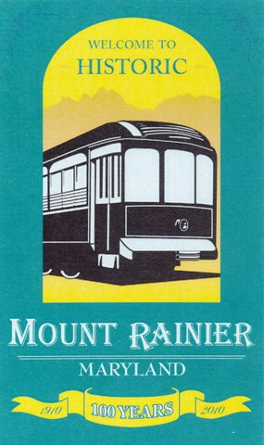
Introduced and Read____________________, 2014
Adopted_________________, 2014
Posted_________to_______________, 2014

CITY OF MOUNT RAINIER
RESOLTUION 10-2014
(Drafted by City Manager)

A Resolution setting forth the City of Mount Rainier Commitment to Obesity Prevention and Complete Streets Program

WHEREAS, in January 2013, the Maryland Municipal League entered into a memorandum of understanding with the Institute for Public Health Innovation to work collaboratively on the HEALTH Cities and Towns Campaign; and

WHEREAS, the City has the ability to affect the health of its residents; and

WHEREAS, planning and constructing a built environment that encourages walking, biking, and other forms of physical activity can promote health; and

WHEREAS, high rates of costly chronic disease among both children and adults are correlated to environments with few or no options for healthy eating and active living; and

WHEREAS, more than half of Maryland’s adults are overweight or obese and therefore at risk for many chronic conditions including diabetes, heart disease, cancer, arthritis, stroke, and hypertension; and

WHEREAS, one in three youth in Maryland is overweight or obese; and

WHEREAS , more children are being diagnosed with diseases linked to overweight and obesity previously seen only in adults, such as Type 2 diabetes and heart disease; and

WHEREAS, the current generation of children are expected to have shorter lives than their parents due to the consequences of obesity; and

WHEREAS, obesity takes a tremendous toll on the health, productivity of all Marylanders;

WHEREAS, the annual cost to Maryland – in medical bills, workers compensation and lost productivity – for overweight obesity and physical inactivity exceeds $3 billion;

WHEREAS, supporting the health of residents and the local workforce would decrease chronic disease and health care costs and increase productivity; and

WHEREAS, .the City of Mount Rainier has committed to decreasing its childhood obesity rate by 2020;

NOW, THEREFORE, LET IT BE RESOLOVED that the Mayor and Council of the City of Mount Rainier hereby recognize that obesity is a serious public health threat to the health and well-being of adults, children, and families in the City of Mount Rainier, and a commitment is needed to put healthy choices within reach of all residents. While individual lifestyle changes are necessary, individual effort alone is insufficient to combat obesity’s rising tide. Significant societal and environmental changes are needed to support individual efforts to make healthier choices. To that end, the City of Mount Rainier adopts this Healthy Eating, Active Living Resolution:

COMMUNITY DESIGN/PHYSICAL ENVIRONMENT

BE IT FURTHER RESOLVED that the City of Mount Rainier Director of Economic Development, engineers, or other personnel responsible for the design and construction of parks, neighborhoods, streets, and business areas should make every effort to:

- Design streets/roads to be safe for all users (mo9torists, bicycles, pedestrians, handicapped) using the following strategy:
- Adopt a Complete Streets Policy

ACCESS TO AFFORDABLE NUTRITIOUS FOODS

BE IT FURTHER RESOLVED that the City of Mount Rainier Director of Economic Development or other personnel responsible for the design of parks, neighborhoods, streets, and business areas, should make every effort to:

- Create/promote farmers’ markets using the following strategy:
- Encourage SNAP/EBT to be accepted at farmer’s market.

MUNICIPAL WORKPLACE WELLNESS

BE IT FURTHER RESOLVED that in order to promote wellness within the City of Mount Rainier, and to set an example for other businesses, the City pledges to adopt and implement a workplace wellness policy that will:

- Make healthy foods available in the municipal workplace using the following strategy:
- Establish a healthy vending policy

IMIPLEMENTATION

BE IT FURTHER RESOLVED that the head of each aff4ected agency or department should report back to the Mayor and Council annually regarding steps taken to implement the Resolution, additional steps planned, and any desired actions that would need to be taken by the Council.

BE IT FURTHER RESOLVED that the City of Mount Rainier staff shall work with HEAL Cities and Towns Campaign Staff to explore HEAL policies and to identify those policies that are suitable for the City of Mount Rainier unique local circumstances.

BE IT FURTHER RESOLOVED that staff will report back to the Mayor and Council with recommendations not later than 120 days from the date of this Resolution.

Attest:

_____________________________ ____________________________________
Jeannelle B. Wallace, City Manager Malinda Miles, Mayor

____________________________________
Jimmy Tarlau, Councilmember

____________________________________
Jesse Christopherson, Councilmember

____________________________________
Ivy R. Thompson, Councilmember

____________________________________
Brent Bolin, Councilmember

