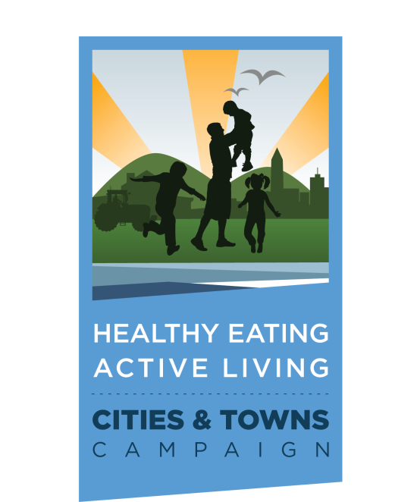

HEALTHY EATING ACTIVE LIVING SOMERSET RESOLUTION

PURPOSE AND INTRODUCTION

Cities and their residents face increased medical costs and diminished quality of life due to the epidemic of obesity and overweight. City leaders across Maryland are addressing the crisis by implementing land use and workplace wellness policies that encourage physical activity and nutritious eating.

The Healthy Eating Active Living (HEAL) Cities & Towns Campaign began in 2012 when the Institute for Public Health Innovation embarked on the initiative. Through a strategic partnership with the Maryland Municipal League, the HEAL Cities & Towns Campaign provides coaching and technical assistance to municipal leaders to adopt local policies that promote access to healthy, affordable foods, convenient access to opportunities for physical activity and recreation, and workplace wellness. These policies set the framework for healthy, prosperous communities where people live, learn, work, play, and worship.

All Maryland cities and towns that adopt this resolution or policies encouraging physical activity and access to healthy, affordable foods are eligible to be a Healthy Eating Active Living City/Town and upon review and approval, become eligible for public relations and marketing resources including use of the HEAL Cities & Towns logo.

Please contact the campaign and share your adopted resolution and supporting policies.

www.healcitiesmidatlantic.org

PREAMBLE
RESOLUTION NO. 1 SETTING FORTH SOMERSET’S
COMMITMENT TO ENCOURAGE HEALTHY EATING AND ACTIVE LIVING FOR ALL RESIDENTS

WHEREAS, the City/Town has the ability to affect the health of its residents; and

WHEREAS, planning and constructing a built environment that encourages walking, biking, and other forms of physical activity can promote health; and

WHEREAS, high rates of costly chronic disease among both children and adults are correlated to environments with few or no options for healthy eating and active living; and

WHEREAS, more than half of Maryland’s adults are overweight or obese and therefore at risk for many chronic conditions including diabetes, heart disease, cancer, arthritis, stroke, and, hypertension; and

WHEREAS, one in three youth in Maryland is overweight or obese; and

WHEREAS, more children are being diagnosed with diseases linked to overweight and obesity previously seen only in adults, such as Type 2 diabetes and heart disease; and

WHEREAS, the current generation of children are expected to have shorter lives than their parents due to the consequences of obesity; and

WHEREAS, obesity takes a tremendous toll on the health, productivity of all Marylanders;

WHEREAS, the annual cost to Maryland—in medical bills, workers compensation and lost productivity— for overweight, obesity, and physical inactivity exceeds $3 billion;

WHEREAS, teens and adults who consume one or more sodas or sugar sweetened beverages per day are more likely to be overweight or obese;

WHEREAS, supporting the health of residents and the local workforce would decrease chronic disease and health care costs and increase productivity; and

WHEREAS, Montgomery County has the lowest adult obesity rate in Maryland, and Somerset wants to help maintain that rank; and

NOW, THEREFORE, LET IT BE RESOLVED that the Somerset Town Council hereby recognized that obesity is a serious public health threat to the health and wellbeing of adults, children and families in the town of Somerset and a commitment is needed to encourage healthy eating and active living. While individual lifestyle changes are necessary, individual effort alone is insufficient to combat obesity’s rising tide. Significant societal and environmental changes are needed to support individual efforts to make healthier choices. To that end, Somerset adopts this Healthy Eating Active Living resolution:

- Built Environment

BE IT FURTHER RESOLVED that Somerset committees, elected officials, and staff responsible for the design and construction of parks and streets should make every effort to:

- Plan and construct a built environment that encourages walking, biking and other forms of physical activity including capital improvement projects;
- Expand community access to indoor and outdoor public facilities through joint use agreements with schools and/or other partners;
- Workplace Wellness

BE IT FURTHER RESOLVED that in order to promote wellness within Somerset, and to set an example for other businesses, Somerset pledges to adopt and implement a workplace wellness policy that will:
Select your city’s specific policy goals from among the following menu.
Work with the HEAL staff to determine your stated goals:

- Set nutrition standards that establish availability of healthy options for food offered at town events, town sponsored meetings, served at town facilities and town concessions, and town programs;
- Promote water consumption in all town public facilities and at town-run meetings.

- Healthy Food Access
BE IT FURTHER RESOLVED that Somerset staff, committees, and, elected officials responsible for the design and of parks and streets should make every effort to:

- Support a town-wide education campaign to raise awareness about MyPlate recommendations by placing a MyPlate poster in each town-owned building that serves food (see sample attached).
- Implementation

BE IT FURTHER RESOLVED that Somerset Wellness Group should report back to the Town Council annually regarding steps taken to implement the Resolution, additional steps planned, and any desired actions that would need to be taken by the town council.

BE IT FURTHER RESOLVED that Staff and Somerset Wellness Group shall work with HEAL Cities & Towns Campaign Staff to explore HEAL policies and to identify those policies that are suitable for the City’s unique local circumstances.

BE IT FURTHER RESOLVED Staff and Somerset Wellness Group will report back to this Council with recommendations not later than 90 days from the date of this Resolution.

APPROVED this 7th day of January, 2013.
___________________________________
Mayor of the Town of Somerset, Maryland

